The company is undergoing significant growth changes, and the senior management is concerned that current employees may have some negative sentiments regarding this growth. To get a better understanding as to what is causing employees to leave the organization, a dataset including a categorical attrition variable demonstrating if the employee still works for the company, as well as thirty-four other variables regarding job demographics, salaries, training, and satisfaction, has been provided to find a correlation to the current attrition rates.
An exploratory data analysis has been completed on the dataset to clean the data and set a baseline for this study. Figures 1, 2, and 3 show the python code used to import the necessary Python libraries, read the original dataset, and verify the current datasets.
Fig. 1
Python code used to import necessary libraries:
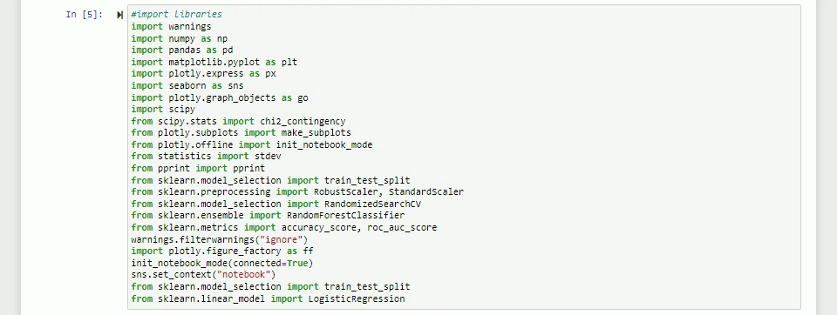
Fig. 2
Python code used to read the original dataset:
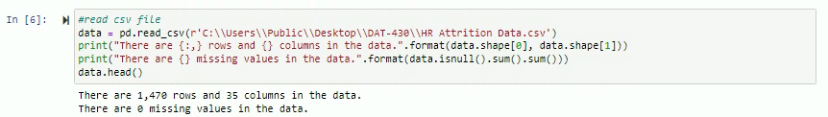
Fig. 3
Python code used to verify the current dataset’s data types:
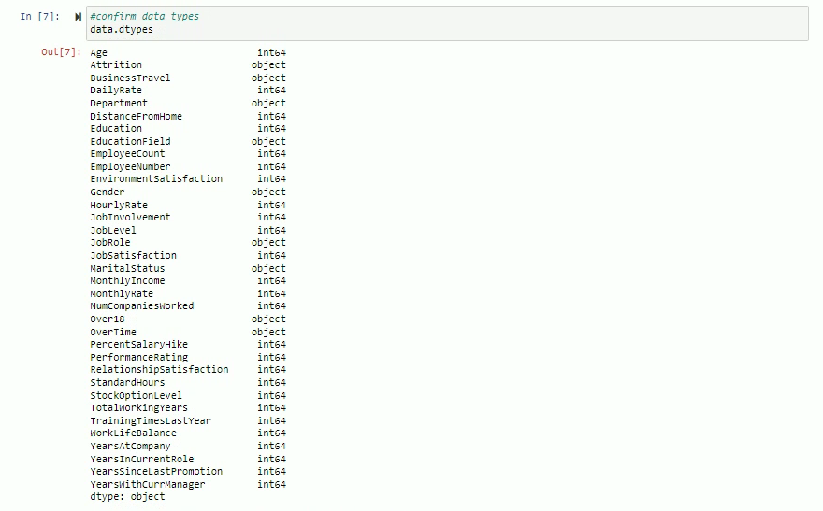The data was prepared to ensure that no missing variables needed to be replaced, as shown in Figure 4. Categorical data types with only two variables (yes/no, true/false, male/female) were converted to binary numerical variables to make for a more straightforward calculation in Figure 5. A histogram of all numeric variables was created to ensure there were no outliers and to identify any attributes for which there was only a single observation (for example, every response was yes, or every response was one), as seen in Figure 6.
Fig. 4
Python code to ensure there are no missing variables:
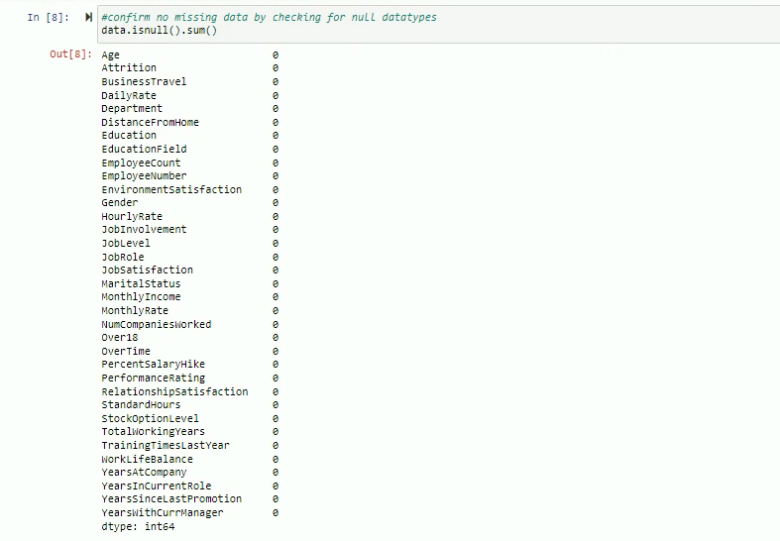
Fig. 5
Python code to convert categorical data types to binary:
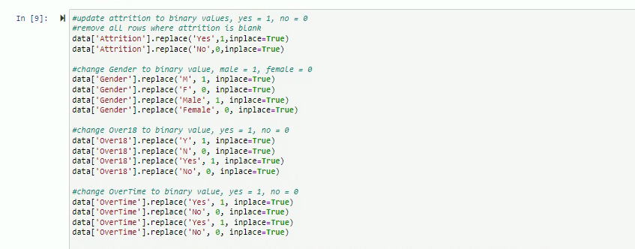
Fig. 6
Histogram chart of all numerical variables:

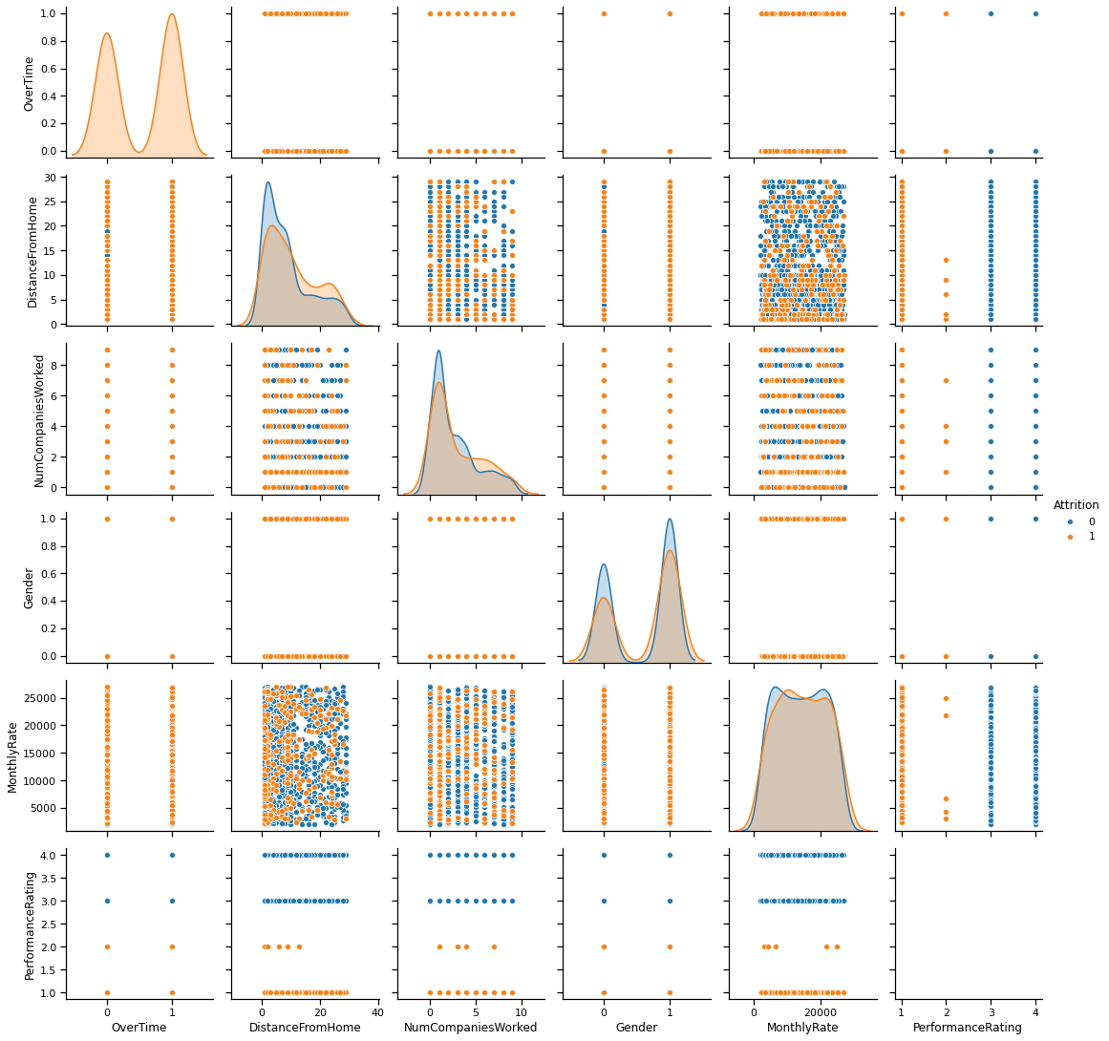

Next, I created visualizations to compare the count of employees that experienced attrition for a variety of different variables:
- Age – Figure 7
- Job Satisfaction – Figure 8
- Monthly Income – Figure 9
- Department – Figure 10
- Environmental – Figure 11
- Work-life Balance – Figure 12
- Number of Companies Worked for – Figure 13
- Years in the Current Role – Figure 14
Fig. 7
Count of employees by attrition and age:
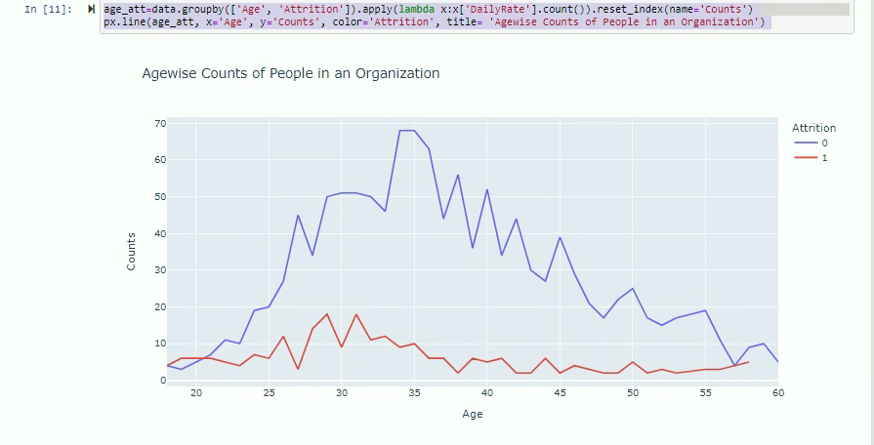
Fig. 8
Count of employees by attrition and job satisfaction:
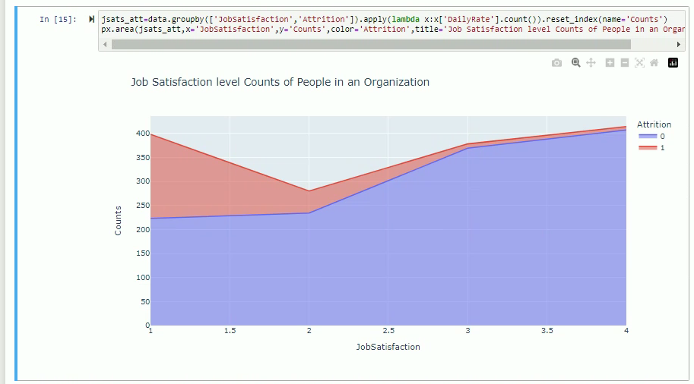
Fig. 9
Count of employees by attrition and monthly income:
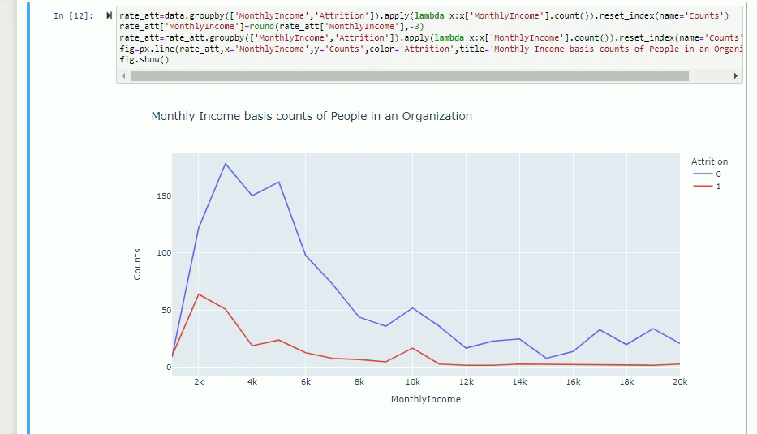
Fig. 10
Count of employees by attrition and department:
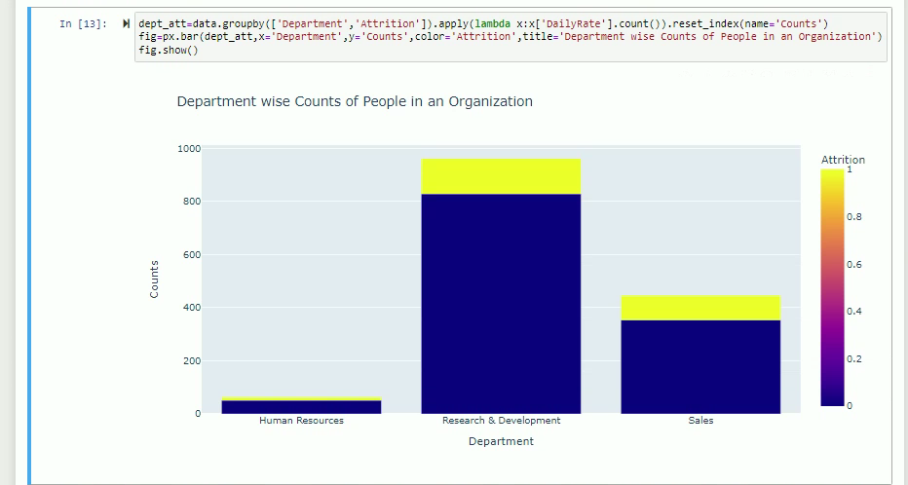
Fig. 11
Count of employees by attrition and environmental satisfaction:
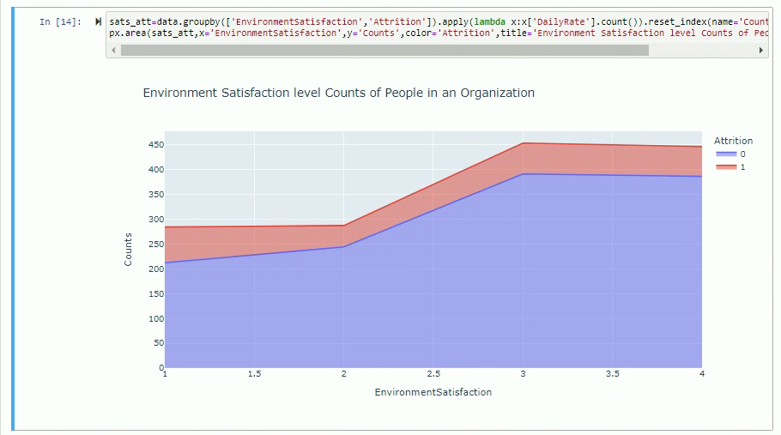
Fig. 12
Count of employees by attrition and work-life balance:
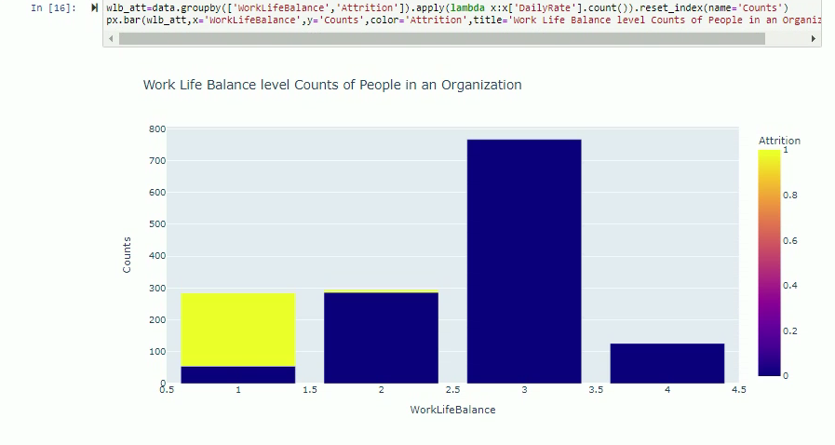
Fig. 13
Count of employees by attrition and number of companies worked for:
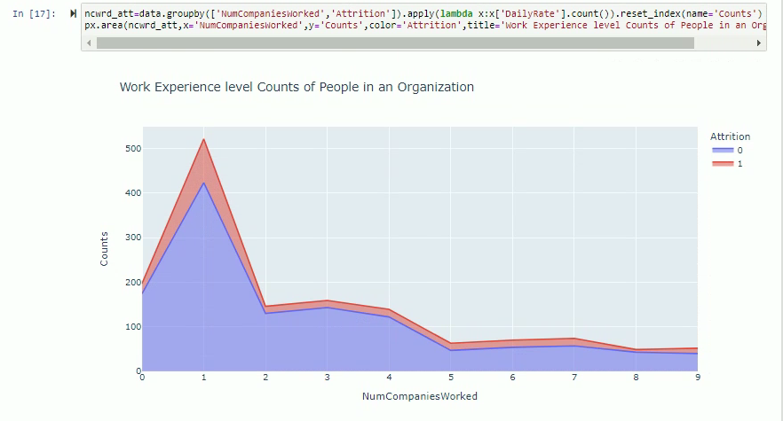
Fig. 14
Count of employees by attrition and years in the current role:
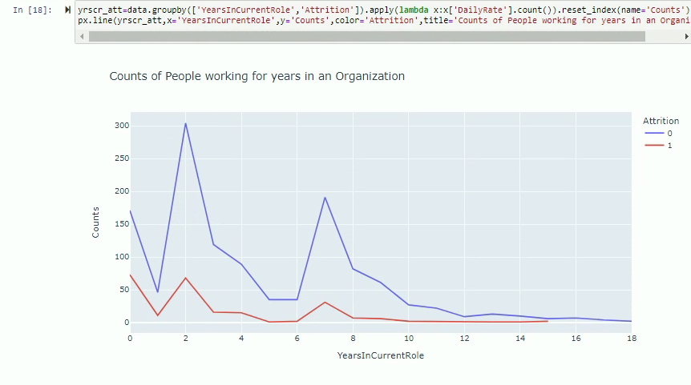
The conclusions that can be gleaned from these visualizations are as follows:
- Figure 7 shows that attrition is most significant for employees between the ages of 28 and 32. After this age group, decay drops significantly.
- The attrition rate is highest among the employees making the least money, as seen in Figure 8. In many cases, employees that accept low-paying entry-level jobs will use the organization as a bridge to achieve a better-paying job as their education and experience increase.
- While the Research and Development team has lost the most staff to attrition (133) since it is the largest department, this only accounts for approximately 14% of their department. HR (19%) is second with 12 of their 51 staff, whereas Sales has lost the most significant percentage of their team (21%).
- The question of environmental satisfaction does not seem to have a significant effect on attrition, as the staff that has left rated this question equally across the four available options. It could be related to how the survey question was worded or presented.
- As employees are more satisfied with their job, the attrition rate decreases. This inverse correlation is not terribly surprising and confirms our expected results from this survey question.
- The staff that has left cited an issue with work-life balance, although it appears that many of the employees have not experienced that.
- The most significant number of employees that have left the organization have only worked for one other company, which tends to support that these are people early in their careers and occupying entry-level positions.
Employees that have left were in their roles from zero to two years, also supporting that they were likely occupying entry-level positions.
The next step in this process is to complete feature selection to identify the variables that impact the model most. A correlation matrix heat map has been generated and appears in Figure 15. The results of this correlation analysis indicate that monthly income, job level, and full working years are the most significant features that should be applied to this model.
Fig. 15
Correlation Matrix Heat Map:
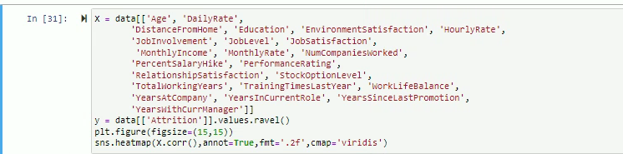
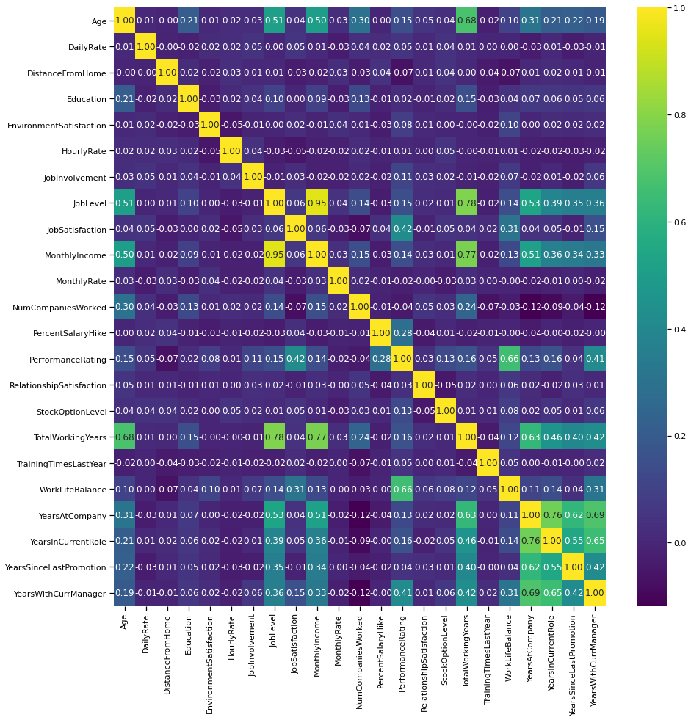
Using the features selected from the correlation matrix, a predictive model can be built using those variables to predict future outcomes. In Figure 16, a logistic regression model was created, including job level, monthly income, total working years, years at the company, and years in the current role to predict the organization’s attrition rate. Using these features, the logistic regression shows that this model is an 84% probability of accurately predicting is an employee will fall victim to attrition or not.
Fig. 16
Logistic Regression Model:
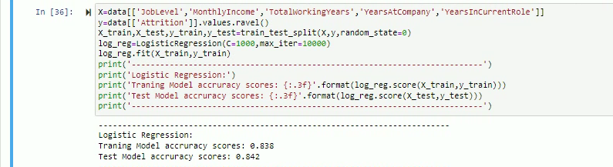
Using the same previously selected features, a random forest regression model was generated using 2, 20, 200, and 2000 trees, as shown in Figures 17 and 18. The Root Square Mean Error (RMSE) for each model iteration was slightly reduced, with the lowest result for the forest with 2000 trees. Since the goal is to minimize the RMSE, this model appears to be appropriate for predicting attrition for the organization using job level, monthly income, total working years, years at the company, and years in the current role.

Fig. 17
Random Forest Regression Model:
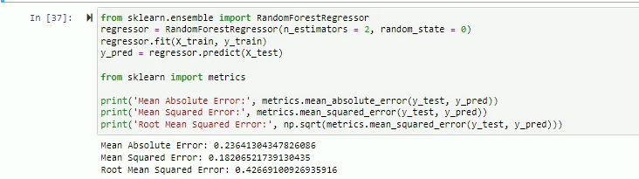
Fig 18
Random Forest Regression Model cont.:
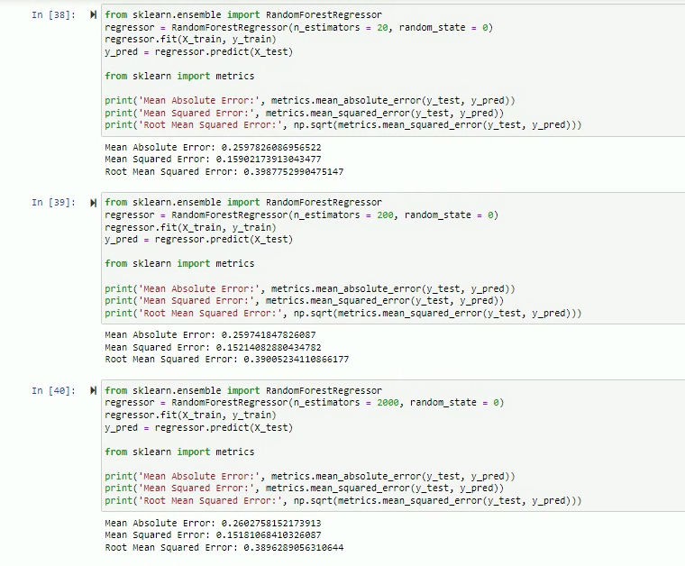
References
IBM HR Analytics Employee Attrition & Performance. (2017, March 31). Kaggle. https://www.kaggle.com/datasets/pavansubhasht/ibm-hr-analytics-attrition-dataset

